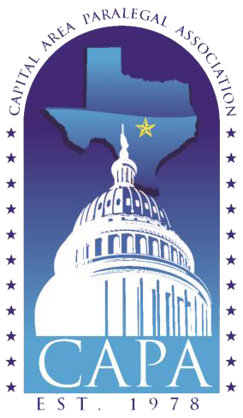

Nancy McLaughlin Scholarship Fund

Deadline to Apply: April 10, 2020 at 5:00pm

Nancy Carmen McLaughlin, CLAS, TPS was a legal assistant at the Law Offices of William Schmidt for twelve years prior to her sudden death on Friday, December 8, 2000. She was dedicated, hard working, and attentive to the needs of clients and her employer.

Nancy received her Certification as a Legal Assistant in 1993 from the National Association of Legal Assistants (“NALA”). She also received a Specialty Certification from NALA and the State Bar of Texas.

Many remember Nancy as a very active member of the Capital Area Paralegal Association (“CAPA”) and the Legal Assistant Division of the State Bar of Texas, now known as the Paralegal Division (“Division”). She spent many hours volunteering for both organizations and motivating others to become involved themselves. She served in many capacities, most notably as Programs Chair and President of CAPA, and as Editor of the Texas Paralegal Journal, published by the Division.

Nancy touched the lives of many people and often you will hear them say they thought of her as family. She was an animal lover and left behind four dogs and a cat. She was a kind and generous friend and devoted her free time to animal causes, Meals on Wheels, and those in need. She is still missed sorely by her many friends.

NANCY McLAUGHLIN
SCHOLARSHIP GUIDELINES

Award: One (1) $250 scholarship for any of the following:
- Texas Advanced Paralegal Seminar (TAPS);
- Certified Paralegal/Certified Legal Assistant Testing Fee (CP/CLA);
- Advanced Paralegal Certification Course Fee (ACP);
- Texas Board of Legal Specialization Testing Fee (TBLS);
- Other CLE that has received credit from NALA, State Bar of Texas and/or TBLS;
- Tuition to paralegal programs at Texas State University, University of Texas, Austin Community College, or other available programs; and
- Membership in CAPA

One scholarship will be awarded. The Scholarship Recipient will be notified by email no later than 30 days after the deadline of April 10, 2020.
The specific use of the award does not need to be identified at the time of the application. It is the responsibility of the scholarship winner to contact the Scholarship Committee Chair(s) for approval of the use and to make arrangements for the award to be paid directly to the provider. Scholarship funds must be used within twelve (12) months of date of award. If the use is less than $250, the remainder, in an amount not to exceed $50, will be given to the recipient to cover other related costs.
Eligibility: All voting, associate, student and emeritus members of CAPA in good standing are eligible.
Criteria: The Scholarship Committee Chair(s) will appoint a committee to judge the scholarship applications on an anonymous basis. The Scholarship Committee Chair and two Board members may participate in the judging process.
The winning essay will be published in the CAPA newsletter and website.
Incomplete applications will not be considered.
The scholarship application and essay must be forwarded to:

Lindsey Reyes
CAPA Scholarship Committee
Email: scholarship@capatx.org

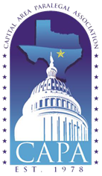

Nancy McLaughlin Scholarship Application

Name:
Home Address:
City/State/Zip:
Home Telephone: |  |  |  |  | Alternate Telephone:
Business Address:
City/State/Zip:
Business Telephone: |  |  |  |  | Business Fax:
Email:

CAPA Membership Type:
Voting | Associate | Student | Lifetime

Does your employer pay for your CLE?
If so, what portion?

Give a detailed description of your reason for seeking a scholarship:
Give a detailed description, if any, for your reasons for financial need. Financial need shall be a contributing factor, but not a requirement. However, if two or more applicants are tied, financial need shall be the determining factor:

Essay Topics
Select one of the following essay topics and submit no more than a two-page, single spaced, typewritten essay with this application.
1. | Why I chose to be a paralegal.
2. | Why Professional Certification is important to the paralegal profession.
3. | Continuing Legal Education as a means of professional development.
4. | What is a paralegal.
5. | What do paralegals contribute to the legal team.
6. | My career goals.
7. | My favorite community service project, including how and why I participate in this project.
8. | How involvement in CAPA has made me a better paralegal.
9. | Other – related topic of applicant’s choosing.

Agreement/Authorization

Should you receive this award, your picture may be published in our newsletters and/or on the website in an effort to promote this scholarship. If this is not acceptable, initial here ________.

I understand this application and supporting information becomes the property of CAPA and it shall have the discretionary authority in all matters pertaining to this award.

I understand that all applications will be reviewed by the Nancy McLaughlin Scholarship Committee to select the recipient of the Scholarship.

I understand that this award may be taxable under the tax laws of the United States and that it is my responsibility to pay such taxes.

I certify that the above information is true and correct.

___________________________________ _____________________________
Signature of Applicant Date

Send completed application and essay via email to:

Lindsey Reyes
CAPA Scholarship Committee
Email: scholarship@capatx.org

